Responses to the Black Death
Escape
The _____________ tried to escape the plague by moving out of infected areas. In The Decameron, c. 1353, author Giovanni Boccaccio describes a fictitious example of ___________ women and three men who escape plague-ridden Florence to go and live in a country villa. People who believed that the plague was God’s way of ________________ them for their sins took pilgrimages to holy places.
What is a holy place people may have made pilgrimage to during the times of the Black Death?
_______________________________________________________________________________________
The Danse Macabre
Throughout Europe, people also performed _____________ about the plague. One of these, the danse macabre, aimed to show that the Black Death made everyone ___________ regardless of her or his wealth or influence in society.
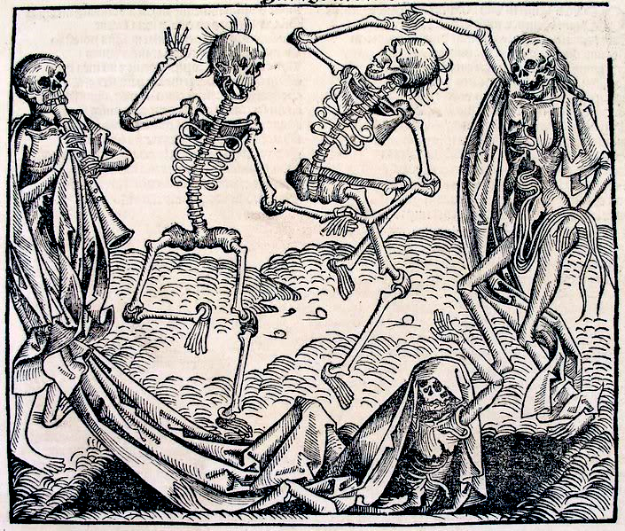
Actors did this by dressing as skeletons and having each skeleton attached to other actors dressed as people from all classes of _____________society. Together they danced the danse macabre – the dance of death.

Danse Macabre images served several purposes, including:
- to help people _______________and share their grief;
- to _______________ each other that death is not only inevitable, but also the great ______________, claiming the high and mighty as well as the humble;
When vulnerable mortals could depict, narrate, and enact the Dance of Death, they gained a subtle sense of control.

Monasteries and the clergy
In medieval times, ________________ played an important role in treating the sick. With the onset of the plague, there was a high death rate amongst monks that led to a severe _____________ of the clergy. During the years of the Black Death, there was often neither the time nor the people to carry out the rituals followed with the dead and dying. About _____________ of the priests died. Others ran away. There was no one to hear someone’s final confession of their sins, and no one to ring the death __________ or conduct a proper religious service and funeral. Anger against the Church’s failure led some people to support other groups that they thought were more effective.
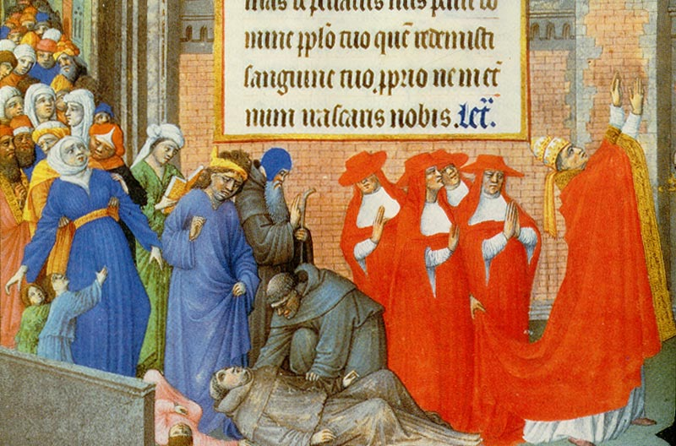

What do you think is happening in the scene above?
___________________________________________________________________________________________________________________________________________________________________________________________________________________________________________________________________________________________________________________________________________________________________________________________________________________________________________________
The Flagellants
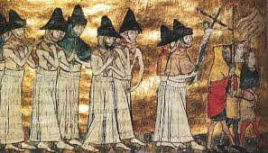
The Flagellants were the most famous group hoping to please God and avoid the plague. They _____________ from town to town for thirty-three and a third days (each day representing a year of Christ’s time on Earth). During their journey they ______________ themselves with strips of leather tipped with iron spikes. At times, they even claimed to have miraculously cured people. It is more likely that they were helping spread the plague. The Pope eventually banned the movement and many Flagellants were ________________.

Finding Scapegoats
Fear, a sense of ________________ and sometimes religious fanaticism caused some people to turn against anyone who seemed in any way unusual. Jews, ____________ and people though to practise witchcraft were all potential victims of those wanting to blame others for a disease they could neither understand nor cure.
Jews
In some areas of Europe, communities believed rumours that Jews poisoned local wells so that they could cause a plague that would destroy the power of the Catholic Church. People:
- ________________ Jewish homes and properties.
- Forced Jews to leave towns and cities
- Arrested and t______________ Jews to give their ‘confessions’
- Rounded them up and _______________ them.
By the early 1350s, there had been more than 300 massacres of Jews, usually in cases where local mobs took control away from local authorities. One of the worst of these occurred in Strasbourg in 1349, when a mob murdered _____________ Jews. Many of the Jews who escaped this treatment left Western Europe and re-established themselves in Eastern Europe.
Other victims
People’s fears made lepers another easy target. People thought their skin disease was a sign that they were evil. They responded by killing lepers just as they killed Jews. In the ______________ world, some leaders interpreted the plague as Allah’s punishment for women sins. As a result, the sultan of Cairo denied women permission to _____________ their homes.
Increased government control
Governments tried, and largely failed, to control food supplies (made more difficult by shortages in labour) and the prices people paid for them. They did this by:
- _______________ food exports
- Banning large-scale fishing
- _______________ grain prices
- Trying to prevent people selling foods for huge profits.
Questions:
- Which of the different responses to the plague would you judge to be: helpful; Illogical; of limited value. Give reasons for your answers.
Response | Helpful, Illogical or Of Limited Value | Why?
Escape
The Flagellants
Finding Scapegoats

Jews

Increased government control

Source 3 – an extract describing the treatment of Jews during the plague years.
Led by the Flagellants, and supported by everybody who was in debt to the Jewish moneylenders, pogroms (organised killings) took place all over Europe, particularly in Germany. In Hamburg, the Jews’ houses were bricked up and the families inside were forced to climb into wine casks, which were nailed up and thrown in the river. The citizens of Basle locked Jews in a wooden building on an island in the river and burned them to death.
From John Clare, I Was There: Medieval Towns, Bodley Head, London 1992.
- Identify evidence that source 3 provides us about:
- The treatment of Jews during the plague years
- The reasons people turned against them at this time.
- _____________________________________________________________________________________________________________________________________________________________________________________________________________________________________________________________________________________________________________________________________________________________________________________________________________________

- ____________________________________________________________________________________________________________________________________________________________________________________________________________________________________________________________________________________________________________________________________

